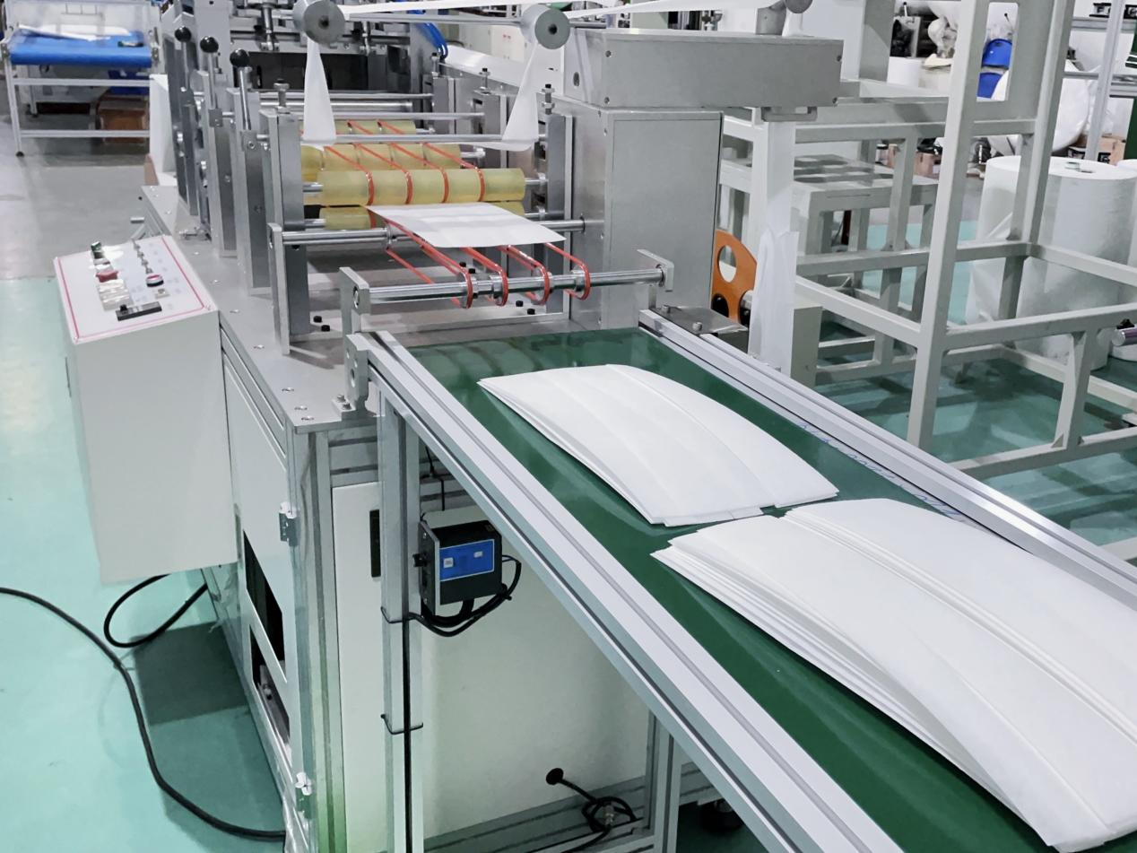

XL-5006梯形小内袋制造机
ULTRASONIC TRAPEZOIDAL SMALL INNER BAG MAKING MACHINE

XL-5006是一台生产初效过滤袋内夹条的专用设备，本机从入料到成品输出，实现高速生产，整理出料。
XL-5006 is a special equipment for the production of primary effect filter bag inner strips.This machine realizes high-speed production from feeding to finished product output, sorting and discharging.

机器特性：
MACHINE CHARACTERISTICS：
- 更换摸具可生产多款尺寸梯形内夹条。并且更换模具简单，快速，节省时间。
- 全机使用铝合金结构，经氧化处理坚固不生锈。
- 更PLC程式控制，变频调速，缺料可自动停机。
- 可调试超音波熔接。
- 稳定性高，性能优异，自动化生产，节省人工，产能高。
- 堆叠计数功能，收集，检验快速。
- Changing the mold can produce a variety of sizes of trapezoidal inner clamping strips. And changing the mold is.simple,fast and saves time.
- The whole machine adopts aluminum alloy structure,which is solid and rust-free after oxidation treatment.
- PLC program control, frequency conversion speed egulation,automotic shutdown when there is no.material.
- Adjustable ultrasonic weding.
- High stability, excellent performance,automatic production,labor saving,high output.
- Stack count function, collection, inspection fast.

Machine Size | 5300(L)*1000(W)*1600(H)
Voltage | 220V
Production capacity | 100pcs/min
Power | 5KW
Barometric pressure | 0.6Mpa

